**Create a Spring Web Project using Maven**

Showing Log:

**public** **static** **void** main(String[] args) {

SpringApplication.*run*(SpringLearnApplication.**class**, args);

System.***out***.println("Main method executed");

}

Dependency Hierarchy:

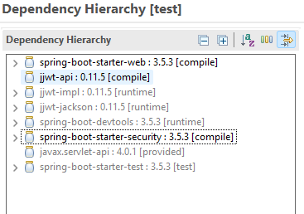

**Spring Core – Load SimpleDateFormat from Spring Configuration XML** 

date-format code:

<?xml version="1.0" encoding="UTF-8"?>

<beans xmlns="http://www.springframework.org/schema/beans"

xmlns:xsi="http://www.w3.org/2001/XMLSchema-instance"

xsi:schemaLocation="http://www.springframework.org/schema/beans

https://www.springframework.org/schema/beans/spring-beans.xsd">

<bean id="dateFormat" class="java.text.SimpleDateFormat">

<constructor-arg value="dd/MM/yyyy"/>

</bean>

</beans>

displaydate method() code:

**public** **static** **void** displayDate() {

ApplicationContext context = **new** ClassPathXmlApplicationContext("date-format.xml");

SimpleDateFormat format = context.getBean("dateFormat", SimpleDateFormat.**class**);

**try** {

Date date = format.parse("31/12/2018");

System.***out***.println("Parsed Date: " + date);

} **catch** (Exception e) {

e.printStackTrace();

}

}

Output on console:

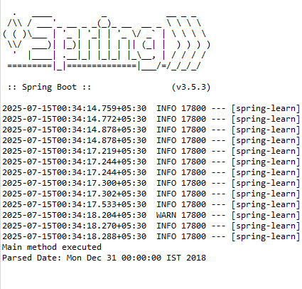

**Hello World RESTful Web Service** 

HelloController Code:

**package** com.cognizant.spring_learn.controller;

**import** org.slf4j.Logger;

**import** org.slf4j.LoggerFactory;

**import** org.springframework.web.bind.annotation.*;

@RestController

**public** **class** HelloController {

**private** **static** **final** Logger ***LOGGER*** = LoggerFactory.*getLogger*(HelloController.**class**);

@GetMapping("/hello")

**public** String sayHello() {

***LOGGER***.info("START - sayHello()");

***LOGGER***.info("END - sayHello()");

**return** "Hello World!!";

}

}

Output:

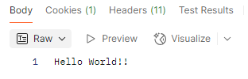

**REST - Country Web Service**

Country Code:

**package** com.cognizant.spring_learn.model;

**public** **class** Country {

**private** String code;

**private** String name;

**public** String getCode() {

**return** code;

}

**public** **void** setCode(String code) {

**this**.code = code;

}

**public** String getName() {

**return** name;

}

**public** **void** setName(String name) {

**this**.name = name;

}

}

CountryController Code:

**package** com.cognizant.spring_learn.controller;

**import** com.cognizant.spring_learn.model.Country;

**import** org.slf4j.Logger;

**import** org.slf4j.LoggerFactory;

**import** org.springframework.context.ApplicationContext;

**import** org.springframework.context.support.ClassPathXmlApplicationContext;

**import** org.springframework.web.bind.annotation.*;

**import** java.util.List;

@RestController

**public** **class** CountryController {

**private** **static** **final** Logger ***LOGGER*** = LoggerFactory.*getLogger*(CountryController.**class**);

@RequestMapping("/country")

**public** Country getCountryIndia() {

***LOGGER***.info("START - getCountryIndia()");

ApplicationContext context = **new** ClassPathXmlApplicationContext("country.xml");

Country country = (Country) context.getBean("in");

***LOGGER***.info("END - getCountryIndia()");

**return** country;

}

@GetMapping("/countries/{code}")

**public** Country getCountry(@PathVariable String code) {

***LOGGER***.info("START - getCountry(): " + code);

ApplicationContext context = **new** ClassPathXmlApplicationContext("country.xml");

List<Country> countryList = (List<Country>) context.getBean("countryList");

Country result = countryList.stream()

.filter(c -> c.getCode().equalsIgnoreCase(code))

.findFirst()

.orElse(**null**);

***LOGGER***.info("END - getCountry()");

**return** result;

}

}

Country.xml Code:

<?xml version="1.0" encoding="UTF-8"?>

<beans xmlns="http://www.springframework.org/schema/beans"

xmlns:xsi="http://www.w3.org/2001/XMLSchema-instance"

xsi:schemaLocation="http://www.springframework.org/schema/beans

http://www.springframework.org/schema/beans/spring-beans.xsd">

<bean id="in" class="com.cognizant.spring_learn.model.Country">

<property name="code" value="IN" />

<property name="name" value="India" />

</bean>

<bean id="countryList" class="java.util.ArrayList">

<constructor-arg>

<list>

<ref bean="in"/>

<bean class="com.cognizant.spring_learn.model.Country">

<property name="code" value="US" />

<property name="name" value="United States" />

</bean>

</list>

</constructor-arg>

</bean>

</beans>

Output:

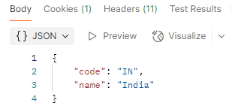

**REST - Get country based on country code** 

CountryService Code:

**package** com.cognizant.spring_learn.service;

**import** com.cognizant.spring_learn.model.Country;

**import** org.springframework.context.ApplicationContext;

**import** org.springframework.context.support.ClassPathXmlApplicationContext;

**import** org.springframework.stereotype.Service;

**import** java.util.List;

@Service

**public** **class** CountryService {

**public** Country getCountry(String code) {

ApplicationContext context = **new** ClassPathXmlApplicationContext("country.xml");

List<Country> countryList = (List<Country>) context.getBean("countryList");

**return** countryList.stream()

.filter(c -> c.getCode().equalsIgnoreCase(code))

.findFirst()

.orElse(**null**);

}

}

Output:

